How to find us
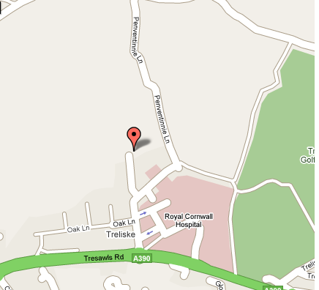

Cornwall Mobility Centre
Tehidy House
Royal Cornwall Hospital
Truro TR1 3LJ

